## EXPERIMENT 8

**AIM:** Write a program to transfer a block of data with and without string instructions and execute the same.

**THEORY:**

**ALGORITHM**:

1. Initialize SI to input the Source String.
2. Initialize DI to store the Destination String.
3. Load CX register with count, i.e. no. of data to be transferred.
4. Clear Direction Flag.
5. Move the contents in source index to destination index using string instructions.
6. Terminate the program.

**Program and Output Screenshot :**

Using String : 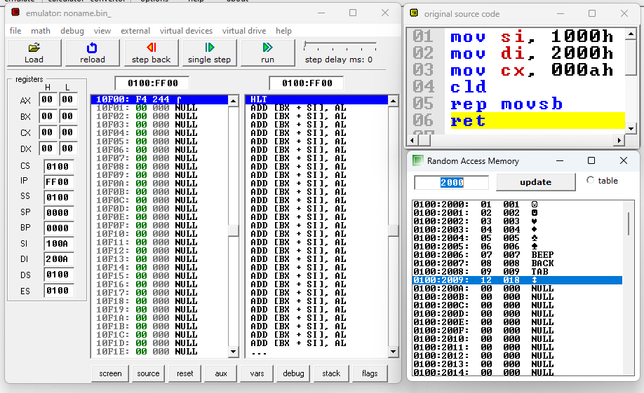

Without String Using loop

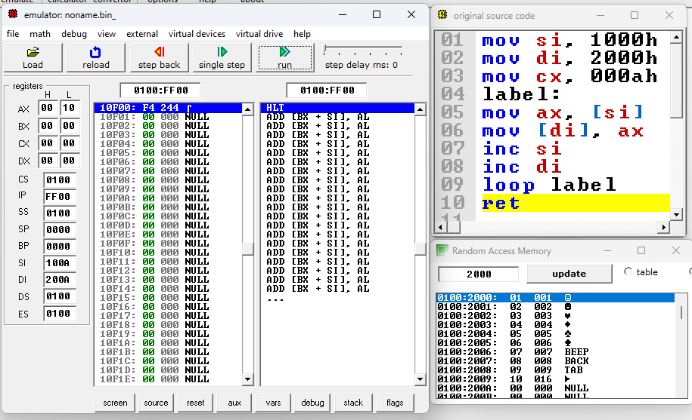

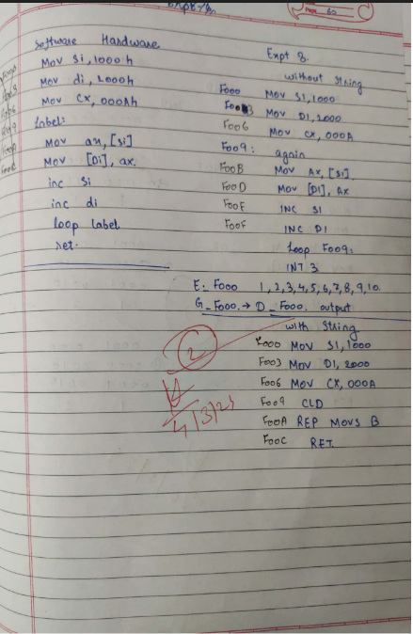

**CONCLUSION**:

Name :

Roll No:

Batch :